«DDK Furniture»

03028, Kyiv, street. Sapnery-Slobidska, 24

We produce ergonomic and durable furniture that easily fit into any interior. Made of ecologically pure pine and fir trees. In the technological process, no harmful or prohibited substances are used. This product is easy to assemble and use.
All our products are delivered in disassembled form in cardboard packaging. Each unit has a set of instructions for cleaning and hardware. To the markets, the products are delivered on Europlates, packed in a stretch and tied up with a ribbon.
Product name | Short name | Number of shelves | Depth, mm | Width, mm | Height, mm | Load on the shelf, kg
Shelf Ran3 | Ran 3 | 3 | 300 | 800 | 850 | 30
Shelf Ran5 | Ran 5 | 5 | 300 | 800 | 1600 | 30
Shelf Ran 6 | Ran 6 | 6 | 300 | 800 | 2000 | 30
Shelving for bottles | WT 1 | 2 | 330 | 370 | 470 | 20
Shelving for bottles | WT 2 | 3 | 330 | 370 | 800 | 20
Shelving for bottles | WT 3 | 4 | 330 | 370 | 1050 | 20
Rack Basic | Basic 3 | 3 | 300 | 800 | 900 | 20
Rack Basic | Basic 4 | 4 | 300 | 800 | 1500 | 20
Rack Basic | Basic 5 | 5 | 300 | 800 | 1700 | 20
Shelf Ler3 | Ler 3 | 3 | 300 | 820 | 900 | 20
Shelf Ler3 | Ler 4 | 4 | 300 | 820 | 1290 | 20
Shelf Ler3 | Ler 5 | 5 | 300 | 820 | 1680 | 20
Wooden box | Dbox 1 | - | 100 | 150 | 80
Wooden box | Dbox 2 | - | 170 | 220 | 80
Wooden box | Dbox 3 | - | 300 | 300 | 150
Wooden box | Dbox 4 | - | 300 | 400 | 150
Wooden box | Dbox 5 | - | 300 | 400 | 240
Wooden box | Dbox 6 | - | 300 | 400 | 140
Wooden box | Dbox 7 | - | 400 | 600 | 140
Wooden box | Dbox 8 | - | 300 | 400 | 140
Wooden box | Dbox 9 | - | 200 | 300 | 140
Corner shelf | C-shelf4s | 4 | 300 | 300 | 1150 | 10
Corner shelf | C-shelf4b | 4 | 400 | 400 | 1150 | 10
Corner shelf | C-shelf3s | 3 | 300 | 300 | 780 | 10
Corner shelf | C-shelf3b | 3 | 400 | 400 | 780 | 10
Decorative bench | LRan1 | 1 | 330 | 800 | 480 | 90
Bedside table | TRan1 | 3 | 410 | 430 | 610 | 90
Coffee table | TRan2 | 2 | 410 | 800 | 610 | 90
Decorative stool | MRan1 | 1 | 330 | 430 | 490 | 90

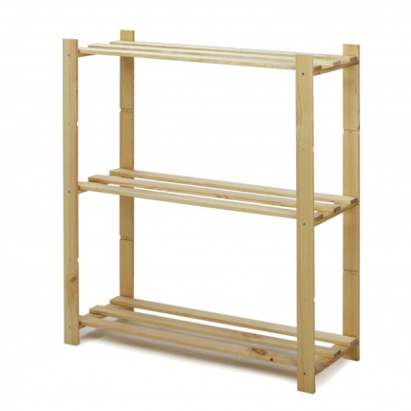 | 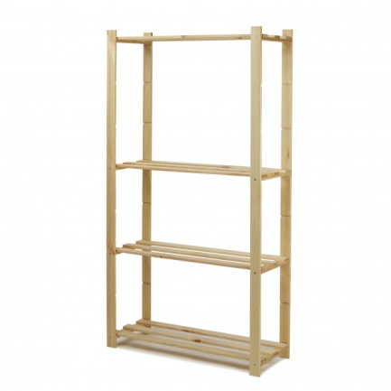 | 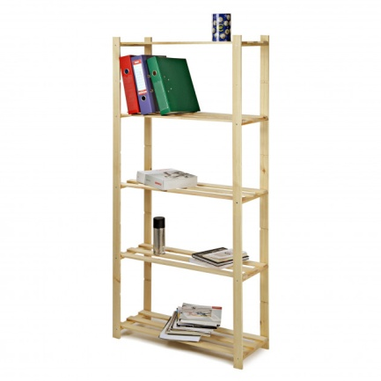
Basic 3 | Basic 4 | Basic 5
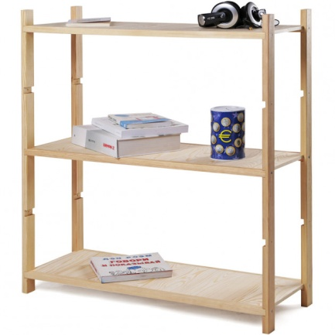 | 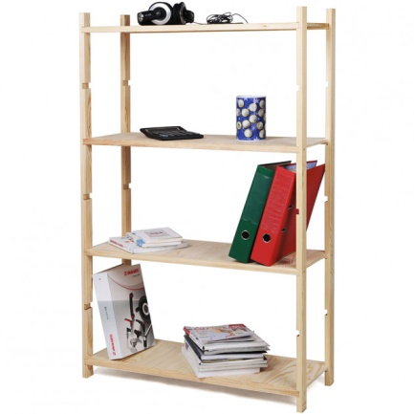 | 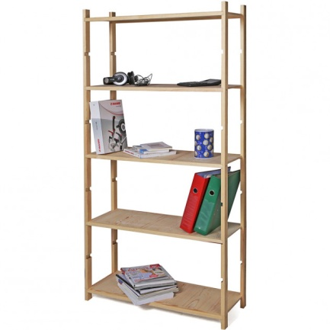
Ler 3 | Ler 4 | Ler5
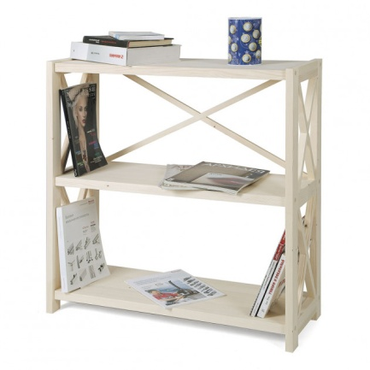 | 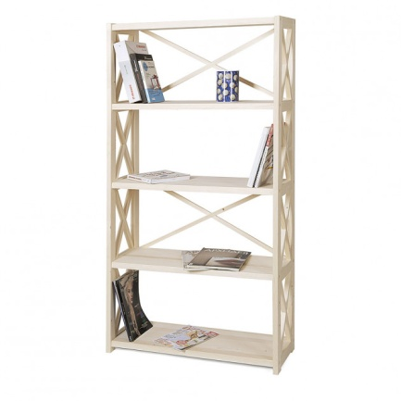 | 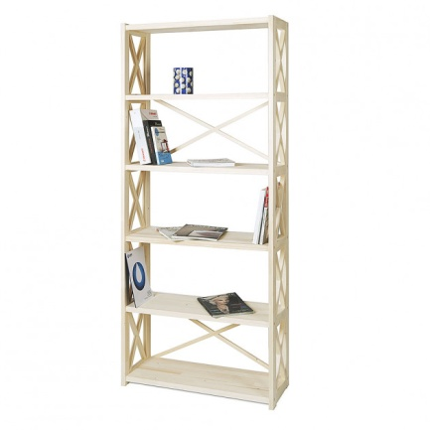
Ran 3 | Ran 5 | Ran 6
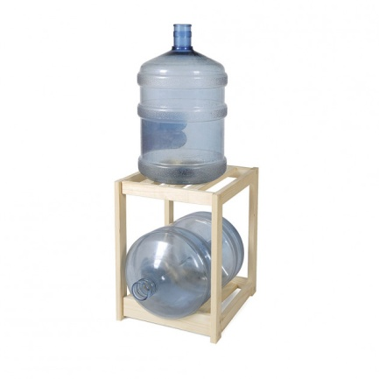 | 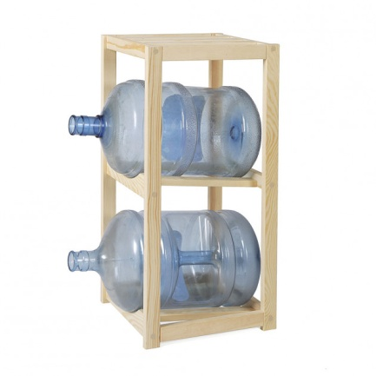 | 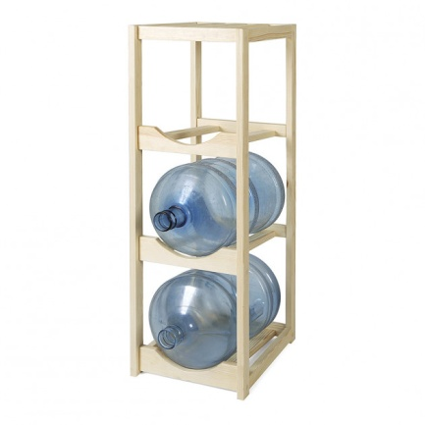
WT 1 | WT 2 | WT 3
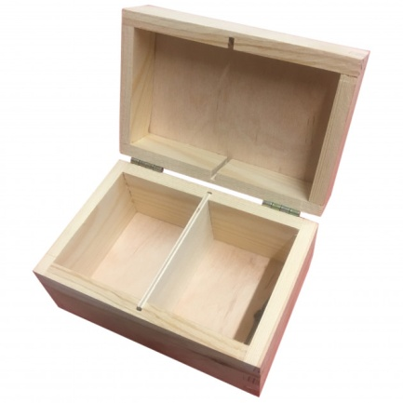 | 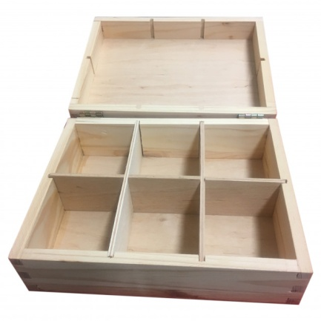 | 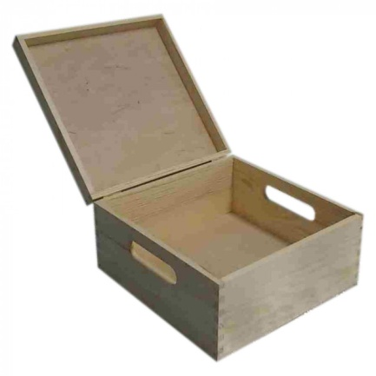
Dbox 1 | Dbox 2 | Dbox 3
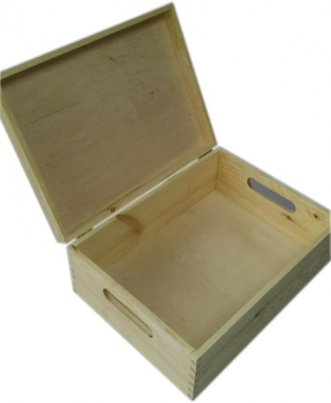 | 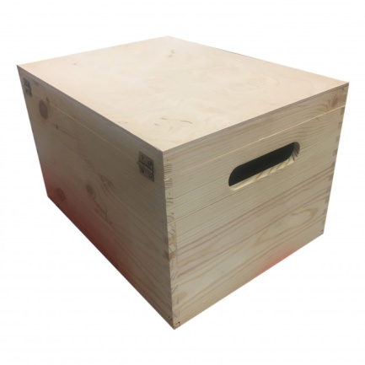 | 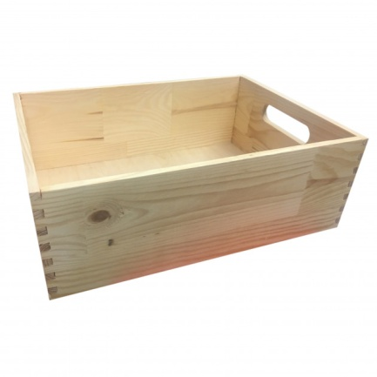
Dbox 4 | Dbox 5 | Dbox 6
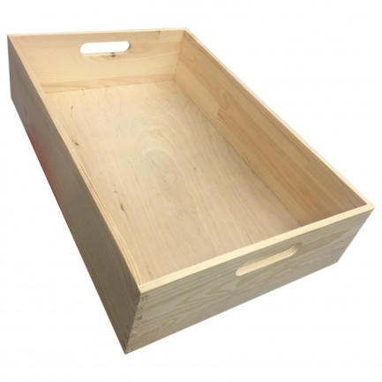 | 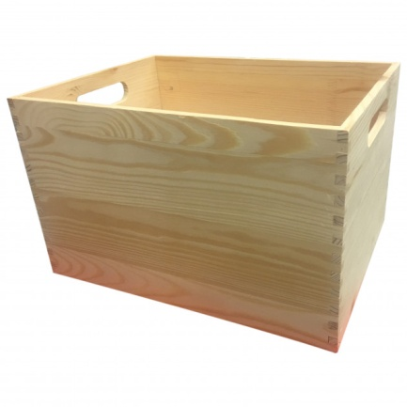 | 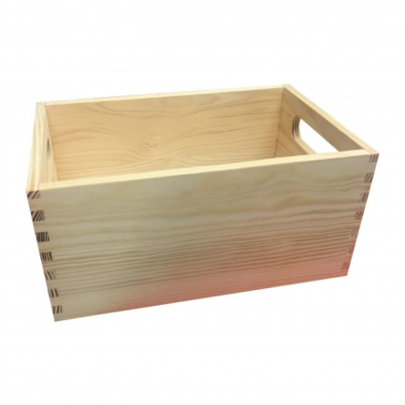
Dbox 7 | Dbox 8 | Dbox 9
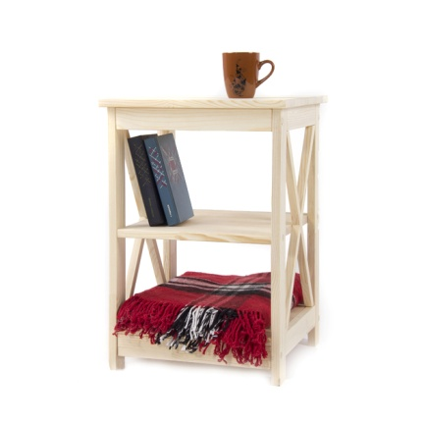 | 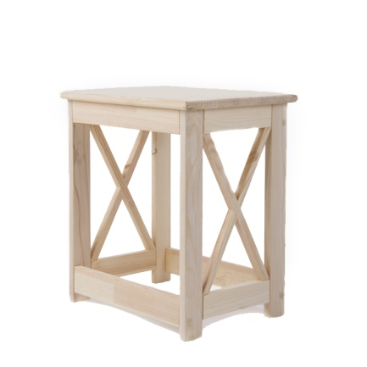 | 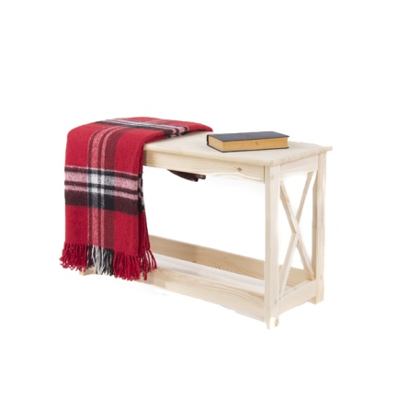
TRan1 | MRan1 | LRan1
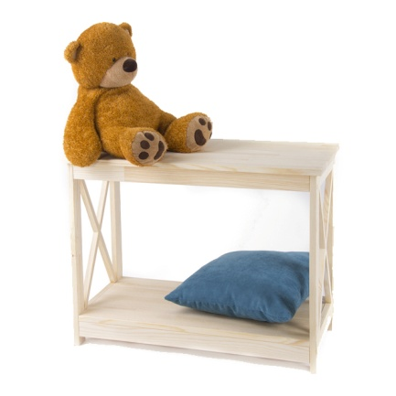 | 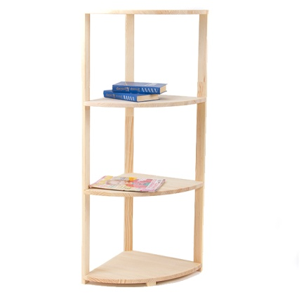 | 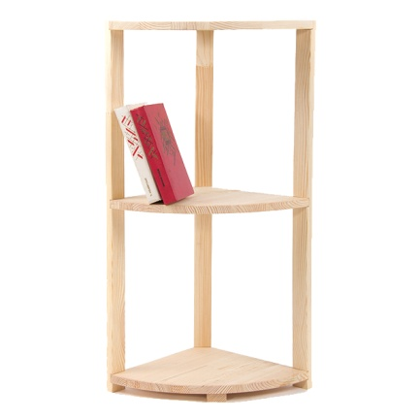
TRan2 | C-shelf4b | C-shelf3s
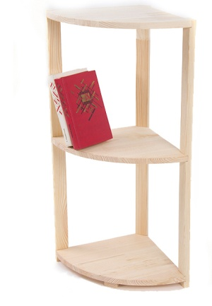 | 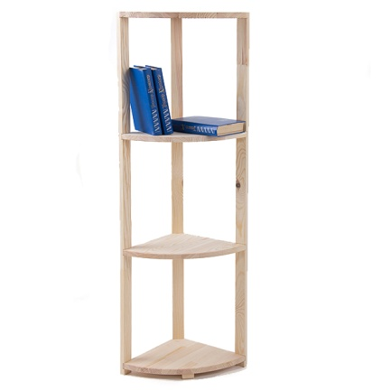
C-shelf3b | C-shelf4s

